Binary spits 🡪 false

Unpruned 🡪 false

Confidence factor 🡪 0.25

Minimal number of objects 🡪 2

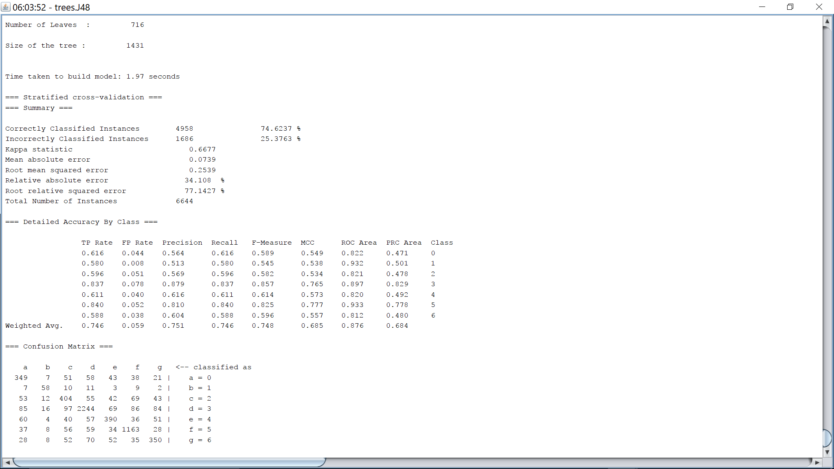

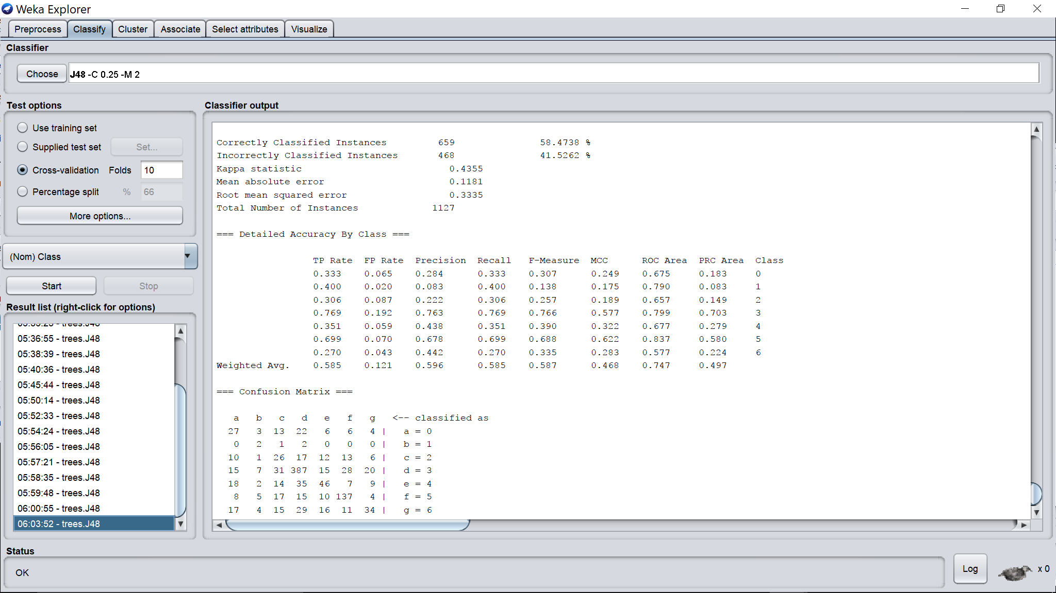

Binary spits 🡪 false

Unpruned 🡪 false

Confidence factor 🡪 0.005

Minimal number of objects 🡪 2

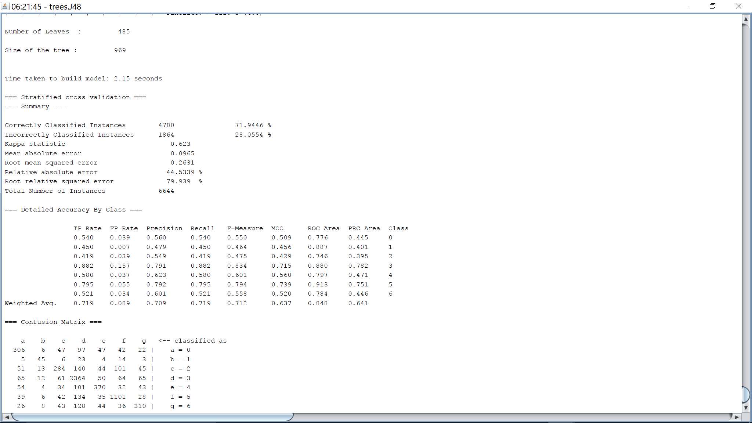

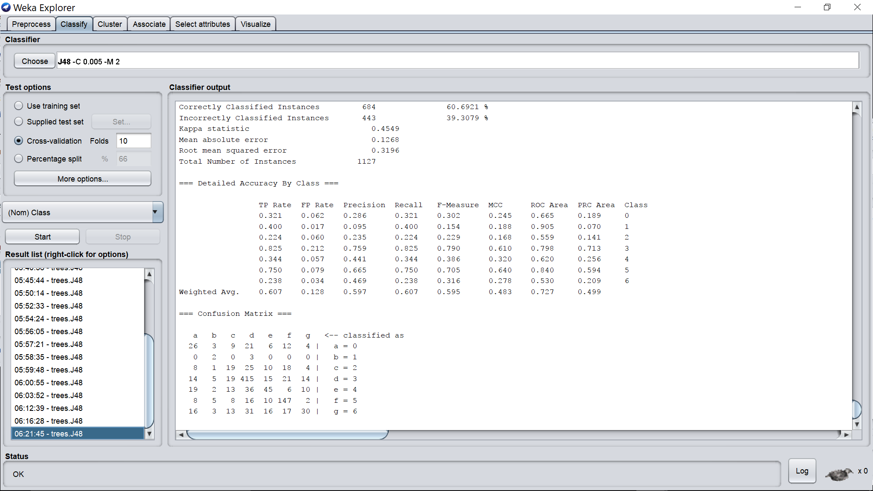

Binary spits 🡪 false

Unpruned 🡪 false

Confidence factor 🡪 0.05

Minimal number of objects 🡪 2

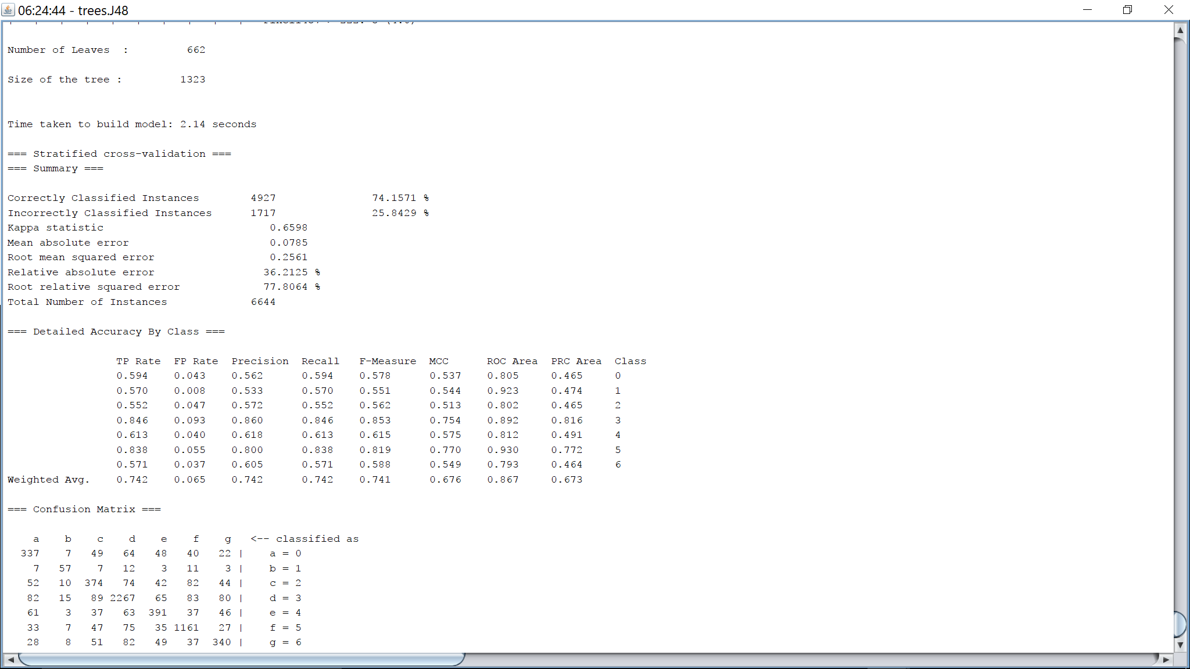

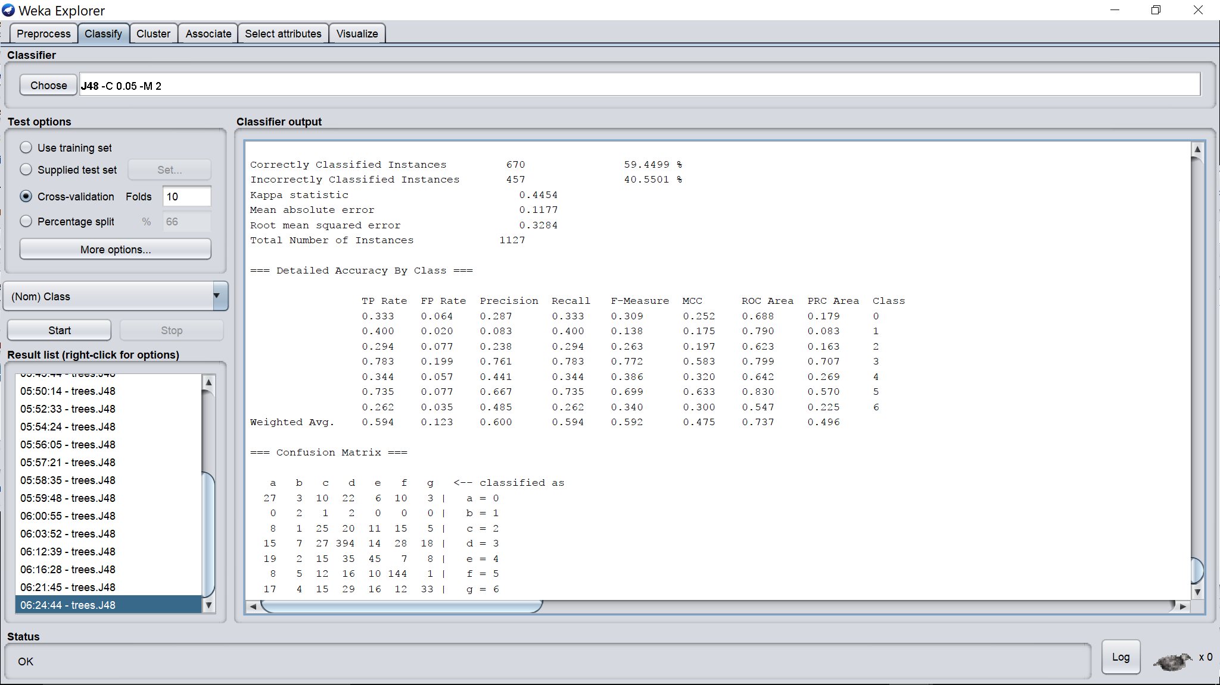

Binary spits 🡪 false

Unpruned 🡪 false

Confidence factor 🡪 0.1

Minimal number of objects 🡪 2

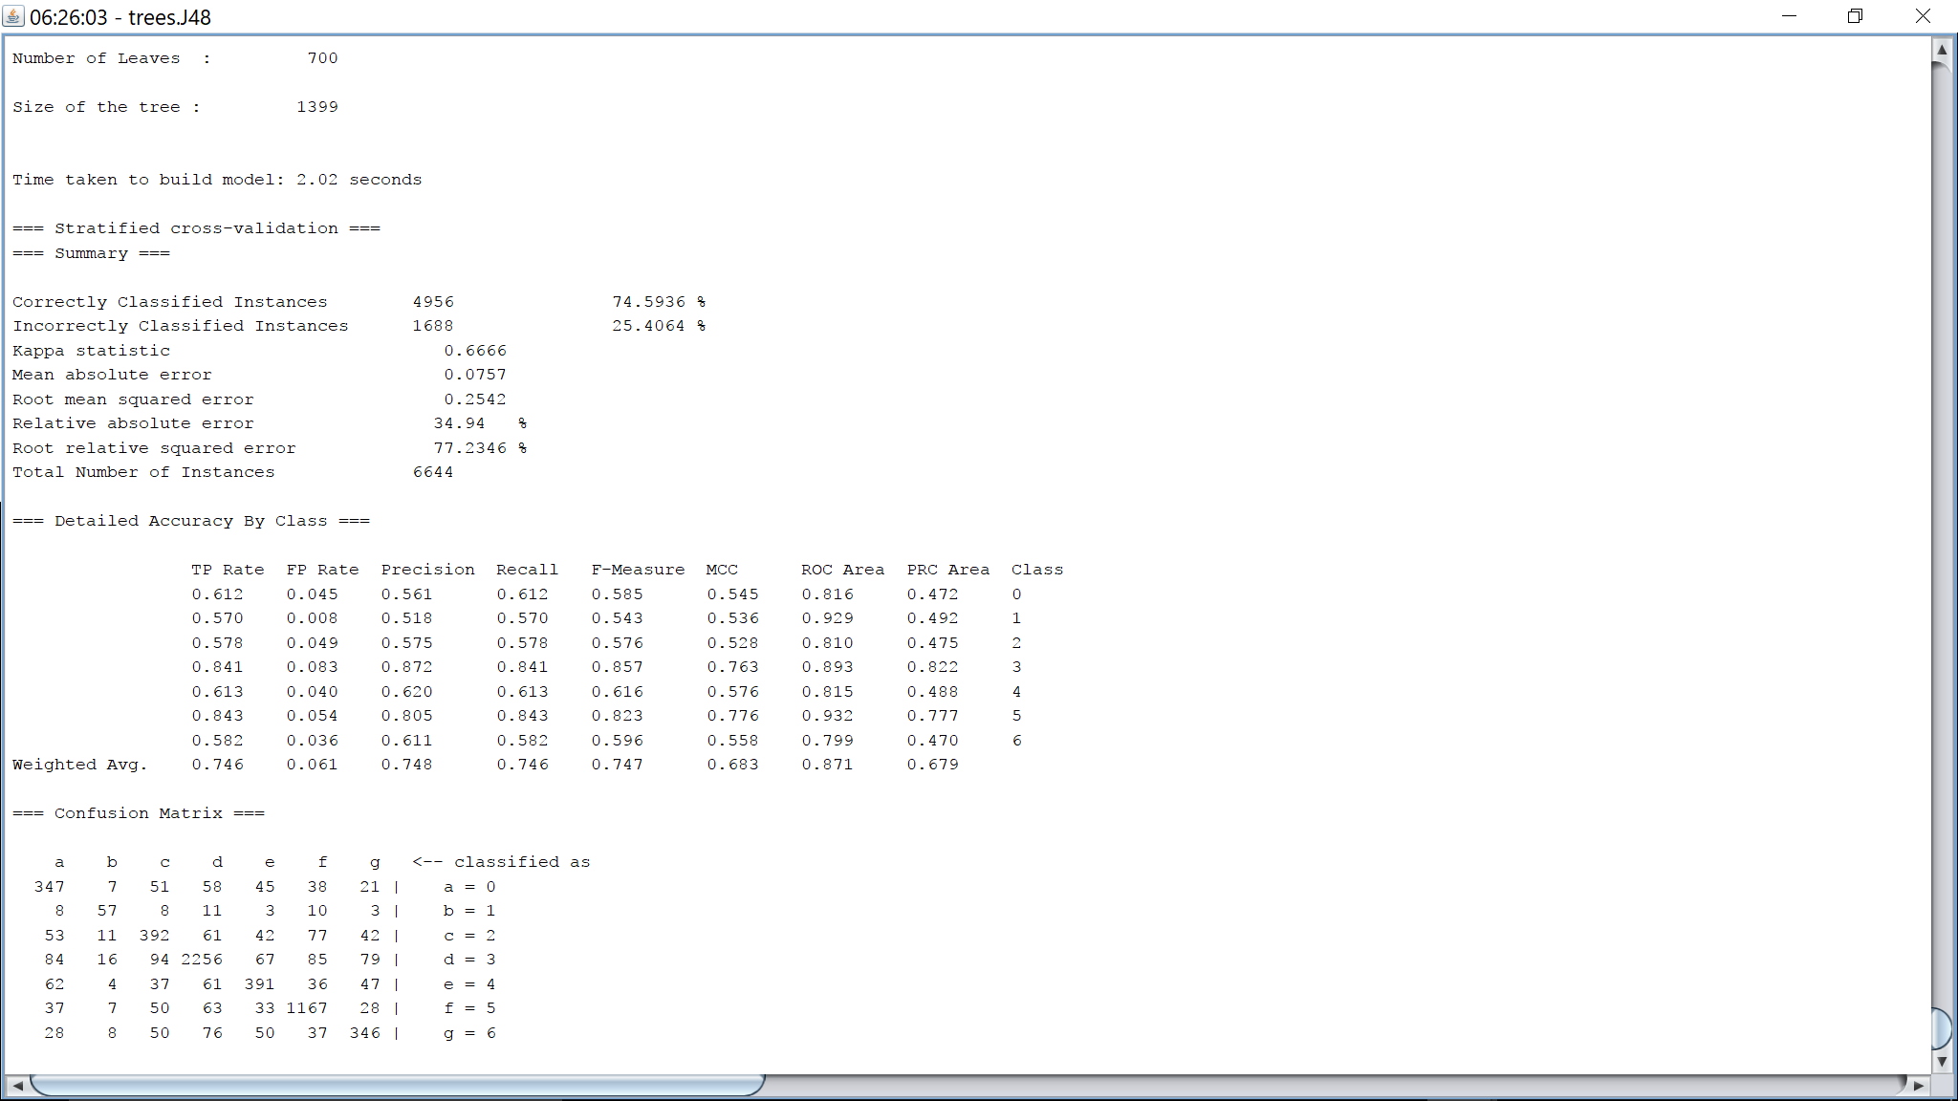

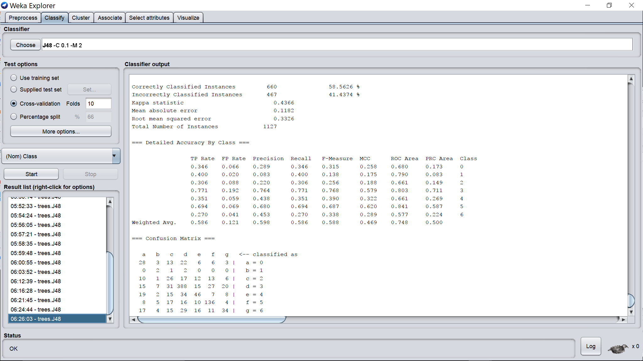

Binary spits 🡪 false

Unpruned 🡪 false

Confidence factor 🡪 0.5

Minimal number of objects 🡪 2

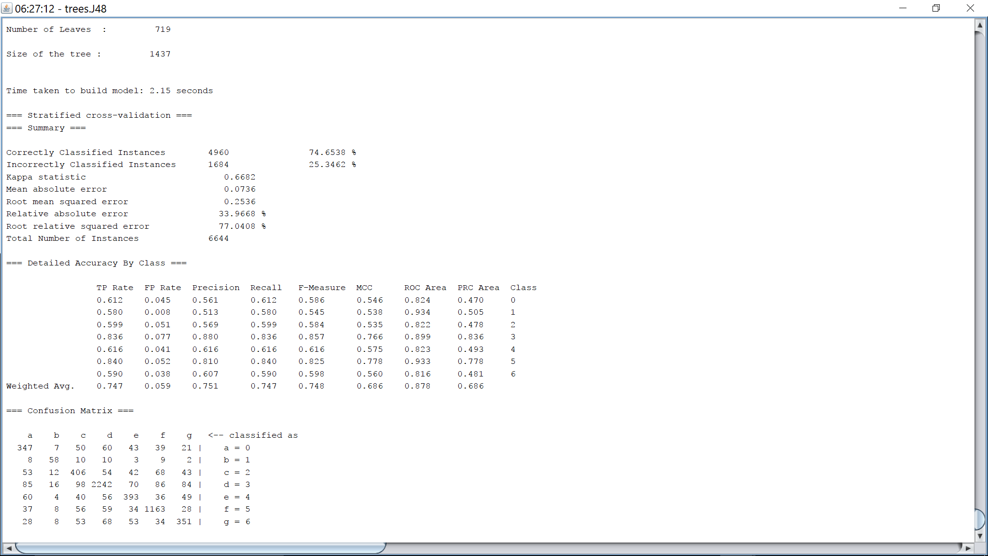

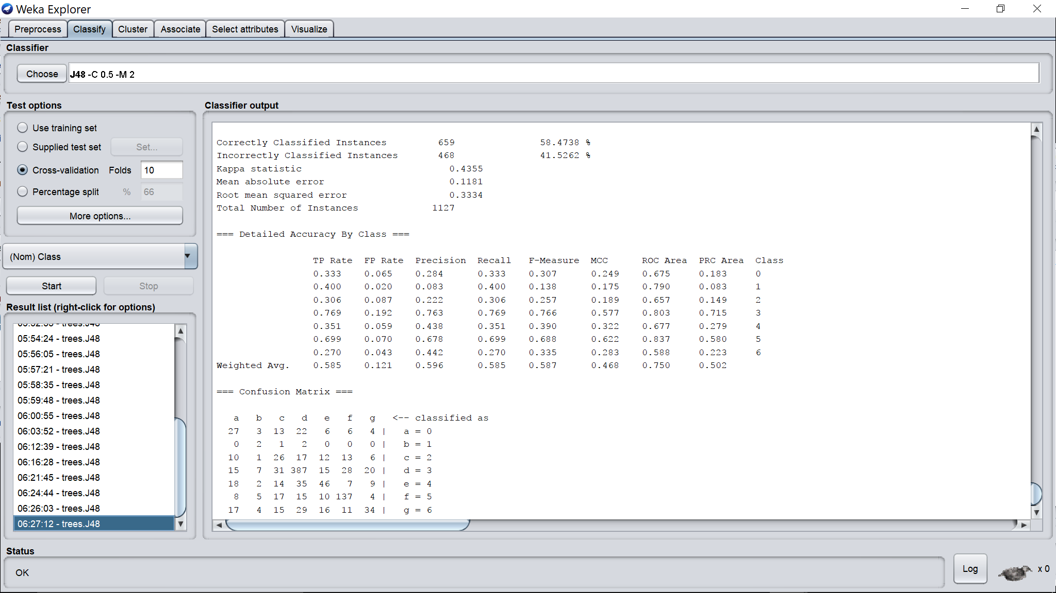

Binary spits 🡪 false

Unpruned 🡪 false

Confidence factor 🡪 1.0

Minimal number of objects 🡪 2

